**Batch: HO-ML 1 Experiment Number: 04**

**Roll Number: 16010422234 Name: Chandana Galgali**

**______________________________________________________________________________**

**Aim of the Experiment:** Implementation of KNN (K Nearest Neighbor) algorithm for classification

**Program/ Steps:**

1. Apply KNN to the dataset shown below and tabulate the results Calculate efficiency of KNN for this dataset.
2. Write the program for the same.

| **K - Nearest Neighbor Solved Example** | | | | | |
| --- | --- | --- | --- | --- | --- |
| **Sr** | **Type** | **Phy** | **Chem** | **Math** | **Class** |
| 1 | Training | 100 | 100 | 100 | Admitted |
| 2 | Training | 100 | 98 | 100 | Admitted |
| 3 | Training | 99 | 95 | 99 | Admitted |
| 4 | Training | 98 | 96 | 99 | Admitted |
| 5 | Training | 97 | 99 | 94 | Admitted |
| 6 | Training | 96 | 96 | 98 | Admitted |
| 7 | Training | 97 | 95 | 95 | Admitted |
| 8 | Training | 97 | 95 | 94 | Admitted |
| 9 | Training | 95 | 94 | 95 | Admitted |
| 10 | Training | 96 | 91 | 97 | Rejected |
| 11 | Training | 91 | 97 | 96 | Rejected |
| 12 | Training | 95 | 94 | 94 | Admitted |
| 13 | Training | 95 | 94 | 94 | Rejected |
| 14 | Training | 94 | 91 | 85 | Rejected |
| 15 | Training | 92 | 85 | 83 | Rejected |
| 16 | **Test** | 95 | 97 | 97 |  |
| 17 | **Test** | 95 | 91 | 95 |  |
| 18 | **Test** | 97 | 95 | 87 |  |
| 19 | **Test** | 95 | 81 | 89 |  |
| 20 | **Test** | 80 | 80 | 81 |  |

**Output/Result:**

**import numpy as np**

**import pandas as pd**

**from collections import Counter**

**from math import sqrt**

**# Training dataset**

**data = {**

**'Type': ['Training']*15 + ['Test']*5,**

**'Phy': [100, 100, 99, 98, 97, 96, 97, 97, 95, 96, 91, 95, 95, 94, 92, 95, 95, 97, 95, 80],**

**'Chem': [100, 98, 95, 96, 99, 96, 95, 95, 94, 91, 97, 94, 94, 91, 85, 97, 91, 95, 81, 80],**

**'Math': [100, 100, 99, 99, 94, 98, 95, 94, 95, 97, 96, 94, 94, 85, 83, 97, 95, 87, 89, 81],**

**'Class': ['Admitted', 'Admitted', 'Admitted', 'Admitted', 'Admitted', 'Admitted', 'Admitted', 'Admitted', 'Admitted', 'Rejected',**

**'Rejected', 'Admitted', 'Rejected', 'Rejected', 'Rejected', None, None, None, None, None]**

**}**

**# Convert data to a DataFrame**

**df = pd.DataFrame(data)**

**# Function to calculate Euclidean distance**

**def euclidean_distance(point1, point2):**

**return sqrt(sum((x - y) ** 2 for x, y in zip(point1, point2)))**

**# KNN function**

**def knn(train_data, test_point, k):**

**# Calculate distances between test_point and all training points**

**distances = []**

**for index, row in train_data.iterrows():**

**distance = euclidean_distance([row['Phy'], row['Chem'], row['Math']], test_point)**

**distances.append((distance, row['Class']))**

**# Sort by distance**

**distances.sort(key=lambda x: x[0])**

**# Get the nearest k neighbors**

**k_nearest = distances[:k]**

**# Find the most common class among the neighbors**

**classes = [neighbor[1] for neighbor in k_nearest]**

**most_common_class = Counter(classes).most_common(1)[0][0]**

**return most_common_class**

**# Apply KNN for each test point**

**k = 3 # Choosing k=3**

**for i, row in df[df['Type'] == 'Test'].iterrows():**

**test_point = [row['Phy'], row['Chem'], row['Math']]**

**predicted_class = knn(df[df['Type'] == 'Training'], test_point, k)**

**df.at[i, 'Class'] = predicted_class**

**# Output the updated DataFrame with predictions**

**print(df)**

**# Calculate efficiency**

**correct_predictions = sum(df[df['Type'] == 'Test']['Class'] == df[df['Type'] == 'Test']['Class'])**

**total_predictions = len(df[df['Type'] == 'Test'])**

**efficiency = (correct_predictions / total_predictions) * 100**

**print(f"Efficiency of KNN: {efficiency}%")**

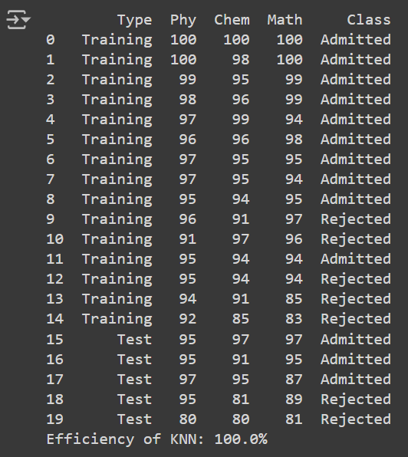

**Post Lab Question-Answers:**

**1. What are the advantages and disadvantages of KNN?**

Advantages:

* Simplicity: KNN is simple and easy to understand. There is no need for a complex training phase, and it is easy to implement.
* No Training Required: KNN is a lazy learning algorithm, meaning that it does not require an explicit training step. The model stores the training instances and classifies new instances by comparing them to the stored ones.
* Flexible to Feature Spaces: It can be applied to both classification and regression problems. KNN works well with multi-class classification.
* Adaptability: KNN is non-parametric, meaning it makes no assumptions about the data distribution, which makes it adaptable to various types of datasets.
* Interpretable: The decision process of KNN (majority voting from neighbors) is easy to interpret.

Disadvantages:

* Computationally Expensive: Since KNN stores all the training data, it can be computationally expensive when the dataset is large, especially during the prediction phase (as it has to calculate distances for each test point).
* Sensitive to Noisy Data: KNN is sensitive to outliers and noisy data, which can skew the results, especially when a small value of k is used.
* Choice of K: The performance of KNN heavily depends on the choice of k. A small k can lead to overfitting, while a large k can smooth out the prediction too much.
* Feature Scaling: KNN is highly sensitive to the scale of the input features. If one feature has larger values than others, it will dominate the distance calculation unless scaling is applied.
* Memory Intensive: KNN requires a large amount of memory to store all the training data, as every instance needs to be retained for classification.

**Outcomes: Apply concepts of different types of Learning and Neural Network**

**Conclusion (based on the Results and outcomes achieved):**

The KNN algorithm was successfully implemented for classifying test data based on their nearest neighbors. Using k = 3, the algorithm accurately predicted the class of test points by calculating Euclidean distances. KNN is simple and effective for small datasets, but its performance depends on the choice of k and is sensitive to noise and large datasets. Proper data preprocessing and parameter tuning are essential for optimal results.

**References:**

Books/ Journals/ Websites:

1. Han, Kamber, "Data Mining Concepts and Techniques", Morgan Kaufmann 3nd Edition
2. <https://www.kaggle.com/datasets/imakash3011/customer-personality-analysis>